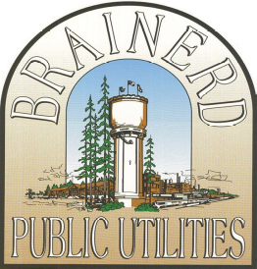

BRAINERD PUBLIC UTILITIES

HEATING AND COOLING REBATE

Terms and Conditions

- To qualify for the Heating and Cooling Rebate, applicants must be a current residential or commercial customer of Brainerd Public Utilities

- Only new products which are described and listed in this application form are eligible for the rebates. If the potential rebate is greater than $3,000, pre-approval from Brainerd Public Utilities is required.

- Old HVAC systems must be properly removed and disposed of. Removed systems cannot be installed somewhere else.

- Customers must submit copies of all project invoices and attach supporting documents, including AHRI Certificate of Product Ratings as specified in the application form.

- All rebates will be reimbursed by check to the customer listed on the application. Please allow 4-6 weeks for rebate processing.

- The completed application and all supporting documents for rebates must be received within 90 days of purchase date shown on sales receipt.

- Incomplete applications will cause delays in payment or denial of the application.

.

E-mail the application and all supporting documentation to Rebates@bpu.org

OR

Mail or fax application and all supporting documentation to:
Brainerd Public Utilities
ATTN: Rebates
P O Box 373
Brainerd MN 56401

Fax: (218)829-4703

IF YOU HAVE ANY ADDITIONAL QUESTIONS
PLEASE CONTACT JULIE AT 218-825-3203 OR jbatters@bpu.org

